Name: | ___________________________________________________ |  |  | Date: ___________
 | Year 11 Applications  Test 1, 2015  Topics – Substitution & Formulas, Percentages & Rates and Simple & Compound Interest |  |  | 55  = %
Total Time: | 60 minutes
Total Reading: | 5 minutes
Total Working: | 55 minutes
Weighting: | 10% of the semester.
Equipment: | SCSA Formula Sheet; ½ page notes (A4 one side), CAS calculator; Scientific Calculator
SECTION 1: CALCULATOR FREE
Time: | 22 minutes | Marks for Section 1: | 20
Reading: | 2 minutes | Equipment Allowed: | Nil
Working: | 20 minutes

1. | [4 marks: 1 mark each]
 | Find the value of each of the following expressions given that x = 4 and y = 3.
a) | 2x² | b) | (x – 2)³
c) | 6x – 2y | d) | (x + y)²

2. | [3 marks: 1 mark each]
 | Express the following percentages as decimals.
a) | 8.5% | b) | 2%
c) | 115%

3. | [4 marks: 1 mark each]
 | Convert the following to percentages.
a) | 0.25 | b) | ¾
c) | 2.4 | d) | 1½

4. | [3 marks: 1 mark each]
 | Expand and simplify the following expressions.
a) | 4(x ‒ 2) | b) | ‒2(x ‒ 3)
c) | 5x(x + 4)

5. | [6 marks: 1, 1, 2, 2]
 | Solve the following equations.
a) | 4x + 1 = 9 |  | b) | x² = 25
c) | 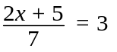 |  | d) | 2(x + 4) = 16

~ END OF TEST SECTION 1 ~

Name: | ___________________________________________________ |  |  | Date: ___________
SECTION 2: CALCULATOR ASSUMED
Time: | 38 minutes | Marks for Section 2: | 35
Reading: | 3 minutes | Equipment Allowed: | ½ page notes (A4 one side),  CAS calculator
Working: | 35 minutes

6. | [3 marks: 1, 2]
 | Courtney invests $25 000 at 2.65% p.a simple interest. Calculate the following.
a) | How much interest would she receive if she invested it for 12 months?
b) | How long would it take for her to have $30 000 (including her original $25 000 investment)?

7. | [3 marks: 1, 2]
 | Answer the following in the spaces provided.
a) | Dayna bought a house for $345 000 and sold it 5 years later for $450 000. What was her percentage profit?
b) | Daniel invested $5000 in a Commonwealth Bank term investment account, where the interest rate of 5.75% p.a. is compounded monthly. If Daniel invested this money for 5 years, how much interest would he have made?

8. | [2 marks: 1 mark each]
 | A department store increases their prices to remain in line with inflation. If the rate of inflation is 2.8%, calculate the new prices of the following:
a) | A Wii U console with Mario Kart originally $395 | b) | A Dragon Quest IX DS Game $49.95

9. | [5 marks: 2, 3]
 | Calculate the best buys for the following questions.
a) | Lemonade is sold in the following packaging 2L for $2.90 or 1.25L for $1.95.
b) | Shanaya wants to buy some Krispy Kreme donuts. They have 2 deals going. Which is the better value for money?  Deal one : $23.50 Deal two: $17.95  This dozen box features: This box features:  * 3 Frosty the Snowman doughnuts * 12 original signature glazed donut  * 3 Christmas Sprinkles doughnuts normally $1.95 each  * 3 Christmas Tree doughnuts  * 3 Snowflake doughnuts  Valued at $28.00

10. |  | [6 marks: 1, 1, 2, 2 ]
 |  | If m = 4 , n = ‒ 3 and p = 2.95, determine:
a) | 2mn ‒ p |  | b) | 3m² + 2np
c) | 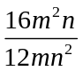 |  | d) | p² + 4n(m ‒ p)

11. | [5 marks: 1, 1, 1, 2]
 | Answer the following questions using the exchange rate table below.

Rates Converter for 1.00 Australian Dollar
Dec 17, 2014 00:34 UTC
Australian Dollar | 1.00 AUD | inv. 1.00 AUD
Euro | 0.657358 | 1.521242
US Dollar | 0.821875 | 1.216729
British Pound | 0.522277 | 1.914694
Indian Rupee | 52.306420 | 0.019118
Canadian Dollar | 0.956119 | 1.045895
New Zealand Dollar | 1.056231 | 0.946763

a) | What is $1 Australian dollar worth in US Dollars? | b) | What is $1 New Zealand Dollar worth in Aust $?
c) | Ammaarah is going overseas on a holiday and wants to exchange $550 Australian into British currency. How much money will she have in British pounds?
d) | Chloe has just arrived home from a holiday in Canada. She had $25 left in Canadian dollars. They charge $5 to exchange money at the local Cash Exchange office. How much money will she end up with after the exchange?

12. | [5 marks: 1, 1, 3]
 | Answer the following questions in the space provided.
a) | A taxi company A charges $5 call out fee and $1.95 per km. If you wanted to catch a taxi to the airport which was a 45km trip, how much will the fare cost?
b) | Another taxi company B charges no call out fee but their rate is $2.50 per km. How much would it cost for the airport trip?
c) | A third Taxi company C charges a flat rate of $100 for airport trips regardless of the km. Which Taxi company would be better if you lived 20km from the airport? (Show all working)

13. | [6 marks: 1, 1, 2, 2]
 | Answer the following questions using the stamp duty table below.

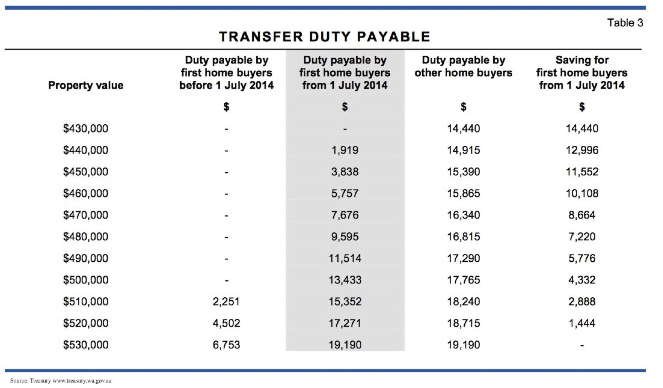

a) | How much stamp duty is payable on a property valued at $520 000 if you are a first home buyer and you bought the property after 1 July 2014?
b) | What is the percentage savings on stamp duty payable if you bought a property for $450 000 after 1 July 2014 and you are a First home buyer?
c) | You bought a property for $520 000 and had $25 000 in savings. How much money would you have to borrow from the bank given you are not a first home buyer?
d) | You were offered a deal to borrow this money using a simple interest payment plan. The simple interest rate was 11% and the loan was for a 20 year period. If you pay equal monthly instalments over this 20 year period, including the interest, how much is each payment?

~ END OF TEST SECTION 2 ~

